Series Hybrid Model

Overall System Model
The model is of a series configuration hybrid vehicle based on [1]. In this type of vehicle, an electric motor drives the wheels using power from a battery or generator. An internal combustion engine is used to turn the generator.
The model can be considered as two feedback loops: one using the vehicle speed and the other the battery charge. The loops intersect at the motor.

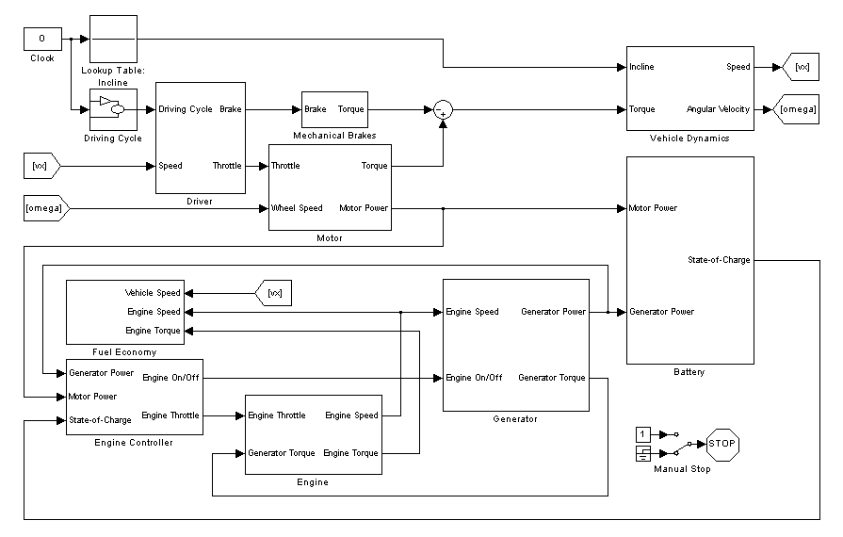
In the upper loop, the driving cycle input describes the vehicle’s desired motion, given in velocity vs. time. The simulated driver compares the vehicle’s current speed with the required speed at that instant of time, and increases the throttle or brake if it doesn’t match. The throttle signal is sent to the electric motor, which outputs a torque based on the throttle level and input voltage. This torque is used in a vehicle dynamics calculation to determine the current speed of the vehicle, which is then compared to the target speed again at the next step in the simulation.
The lower loop is used to control the engine to maintain the battery’s charge level. The engine controller checks the state of charge of the battery, and controls the engine based on the control strategy selected.
The required power by the motor is used as an input signal to the battery and engine controller. If more power is needed than is provided by the generator, current is drawn from the battery to make up the difference. If the generator is producing more power than the motor requires, the excess is sent to the battery.

Vehicle Dynamics Subsystem
This part of the model determines the motion of the vehicle based on the input torque to the wheels and forces that are opposing the motion such as rolling resistance and air drag.
Inputs are torque from the motor and mechanical brakes and the road incline angle
Outputs are the vehicle forward speed and angular velocity of the wheels.

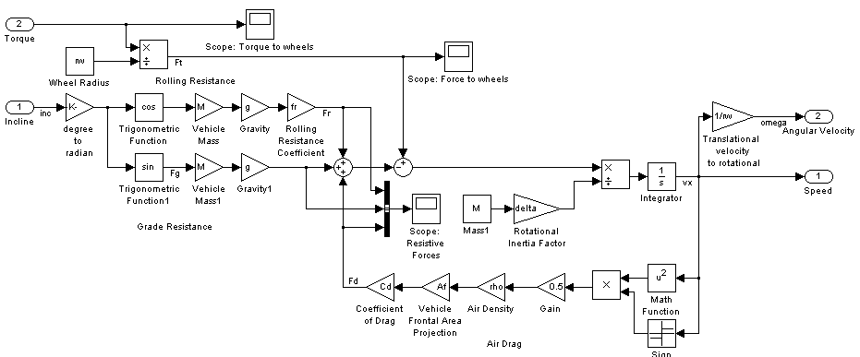
The vehicle’s equation of longitudinal motion is derived from Newton’s second law of motion:
$$ma=F$$
$$Mδ\frac{dv}{dt}=F_{t}-F_{rl}$$
F_{t} is the tractive force to move the vehicle and F_{rl} is the road load force opposing the motion. δ is a mass factor that equivalently converts the rotational inertias of rotating components into translational mass. Torque and force are related by the tire radius:
$$F_{t}=\frac{T}{r_{w}^{0}}$$
Forces that resist the motion are rolling resistance, grade resistance, and aerodynamic drag.
$${F_{rl}=F}_{r}±F_{g}+F_{d}$$

Rolling Resistance
$$F_{r}=Mgf_{r}\cos{α}$$

Grade Resistance
$$F_{g}=Mg\sin{α}$$

Aerodynamic Drag
$$F_{d}=\frac{1}{2}ρA_{f}C_{d}v^{2}$$
$$Mδ\frac{dv}{dt}=F_{t}-Mgf_{r}\cos{α}-Mg\sin{α}-\frac{1}{2}ρA_{f}C_{d}v^{2}$$
The model using the following equation to calculate acceleration (dv/dt) which is integrated to obtain the velocity:
$$\frac{dv}{dt}=\frac{F_{t}-Mgf_{r}\cos{α}-Mg\sin{α}-\frac{1}{2}ρA_{f}C_{d}v^{2}}{Mδ}$$

Angular velocity
Related to linear velocity by rolling radius:
$$ω=\frac{v_{x}}{r_{w}^{0}}$$

Parameters and variables
Symbol | Description | Value | Units
T | Torque | Input to the subsystem | N-m
α | inclination angle | Input to the subsystem | rad
v_{x} | vehicle velocity | Output of the subsystem | m/sec
ω | Angular velocity | Output of the subsystem | rad/sec
M | Vehicle mass | 1200 | kg
C_{d} | vehicle’s drag coefficient | 0.3 | unitless
f_{r} | rolling resistance coefficient | 0.01 | unitless
A_{f} | vehicle’s frontal area projection | 2 | m²
ρ | air density | 1.19 | kg/m³
r_{w}⁰ | rolling radius | 0.3 | m
δ | rotational inertia factor | 1.1 | unitless

Motor Subsystem
The motor subsystem simulates the vehicle’s traction motor. The system calculates torque output by the motor and electrical power needed to produce that torque. It goes through the following steps:
- Convert the input wheel speed into motor RPM using the final drive ratio.
- Determine maximum torque at that speed using a table of max torque vs. speed for the electric motor.
- Use a percentage of motor maximum power based on the input driver throttle. It is negative if braking.
- Determine motor efficiency using a table of efficiency vs. torque and speed.
- Calculate motor input power using $P=\frac{torque x speed}{efficiency}$. When in regenerative braking mode (Torque < 0), it is multiplied by the efficiency instead, since electrical power switches from input to output.
Motor torque and efficiency data are from [2].
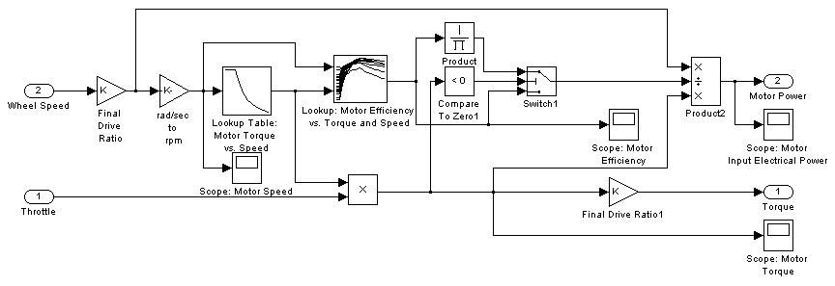

Parameters and variables
Symbol | Description | Value | Units
throttle | Throttle position | Input to the subsystem | unitless
ω | Wheel angular velocity | Input to the subsystem | rad/sec
T_{m} | Motor torque | Output of the subsystem | N-m
P_{m} | Motor electrical power | Output of the subsystem | W
K | Gear ratio | 7 | unitless
η_{m} | efficiency of motor | Lookup table | unitless

Battery Subsystem
The battery subsystem models charging and discharging of the battery. Output is state-of-charge. Inputs are generator power and motor power.
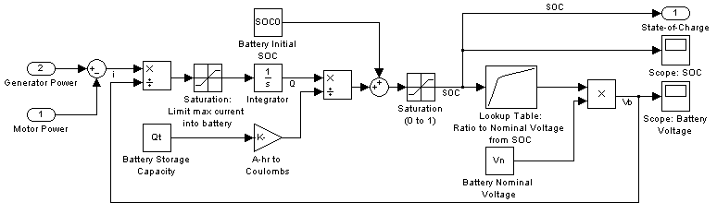
The battery’s voltage is related to its state-of-charge (SOC). SOC is the battery’s charge ratio that ranges from zero (empty) to one (fully charged).
The difference in power between the motor and generator is either drawn from the battery or charges it.
Battery state-of-charge is determined with the coulomb-counting method using the currents drawing from or charging the battery. Current is found by dividing power by voltage. Current is the rate of change of charge:
$$i=\frac{dQ}{dt}=\frac{P}{V_{b}}$$
$$Q=\int_{0}^{t}{idt=\int_{0}^{t}{\frac{P}{V_{b}}dt}}$$
SOC is the ratio charge to max charge. Qt is the charge at maximum capacity. Change in SOC is due to the percentage change in charge:
Final SOC is the battery initial SOC add the SOC after the battery is charged:
$SOC=\frac{Q}{Q_{t}}$
Battery normalized voltage vs SOC [1]
$${SOC}_{f}={SOC}_{0}+SOC$$
The battery’s voltage is a function of the state of charge. A table [1] relates the SOC to the voltage ratio to nominal. Nominal voltage is the voltage at 50% SOC.

Multiply the ratio by nominal voltage to get the terminal voltage:
$$V_{b}=V_{nom}V_{ratio}$$
The battery consists of a number of cells. The nominal voltage parameter will depend on the quantity of cells in the battery. Nominal voltage of a single cell for a lithium-ion battery is about 3.5 V.

Parameters and variables
Symbol | Description | Value | Units
P_{m} | Motor power | Input to the subsystem | W
P_{g} | Generator power | Input to the subsystem | W
SOC | Battery’s final state of charge | Output of the subsystem | unitless
SOC₀ | battery’s initial state ofcharge | 0.75 | unitless
Q_{t} | Battery charge capacity | 40 | A-hr
V_{n} | Battery nominal voltage | 160 | V
I_{b,max} | Max battery current allowed | 25 | A

Brakes Subsystem
Input is brake pedal position. Output is mechanical brake torque.
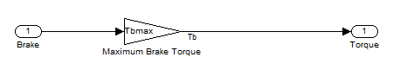
Brake torque: torque proportional to the brake pedal position.

Parameters and Variables
Parameter | Description | Value | Units
T_{b,max} | Maximum Braking Torque | 500 | N-m

Generator
The generator system is set up much the same as the motor, but the operation is reversed. It calculates electric power produced and torque demand on the engine. Power flow is only one direction (mechanical to electrical). The generator characteristics are the same as the motor’s [2].
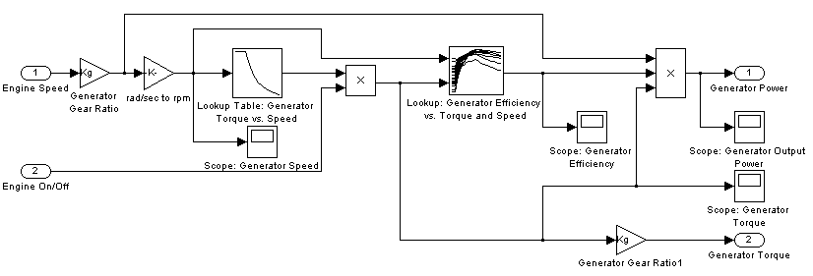

Parameters and Variables
Symbol | Description | Value | Units
Engine on/off | Whether engine is running | Input to the subsystem | 0 or 1
ω_{eng} | Engine Speed | Input to the subsystem | rad/sec
T_{g} | Generator torque | Output of the subsystem | N-m
P_{g} | Generator electrical power | Output of the subsystem | W
K_{g} | Engine/generator Gear ratio | 1 | unitless
η_{m} | efficiency of generator | Lookup table | unitless

Engine
The engine characteristic is modeled using a lookup table of maximum torque vs. speed. The engine throttle scales the torque by the percentage of maximum requested. A separate table is used for closed-throttle torque. Lookup table data is from [2].
A rotational dynamics equation determines the changes in engine speed based on the difference between engine output torque and torque demand by the generator.
Inputs are engine throttle and generator torque. Output is engine speed and torque.
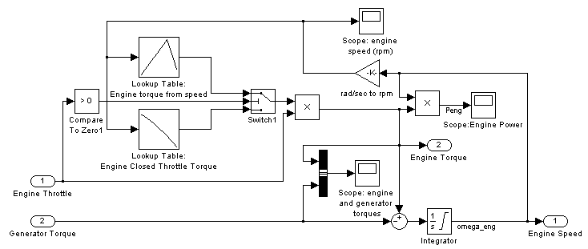
$$\sum{T}=I_{g}α$$
$$T_{ICE}-T_{g}=I_{g}\frac{dω_{eng}}{dt}$$

Power

$$P_{eng}=T_{eng}ω_{eng}$$

Parameters and Variables
E_{th} | Engine throttle level | Input to the subsystem | 0 to 1
T_{g} | Generator Torque | Input to the subsystem | N-m
T_{eng} | Engine Torque | Output of the subsystem | N-m
ω_{eng} | Engine Speed | Output of the subsystem | rad/sec
I_{g} | Engine Inertia | 1 | kg-m²

Engine Controller
A controller adjusts the ICE output to keep the battery charging current constant and determines whether the engine should be running.
- The lower left structure evaluates the conditions that determine whether the engine should operate at all
- The lower structure on right is the timing clock for the simulation. If the battery has been finished charged and the time period is larger than the 100, the simulation will stop. This is only usable with the thermostat control strategy.
- The upper structure on right is a PID controller that adjusts the engine throttle based on an error signal used to control the engine behavior such as engine speed or power.
- The upper left structure determines what power level the generator should operate at (either at maximum or what is demanded by the motor).

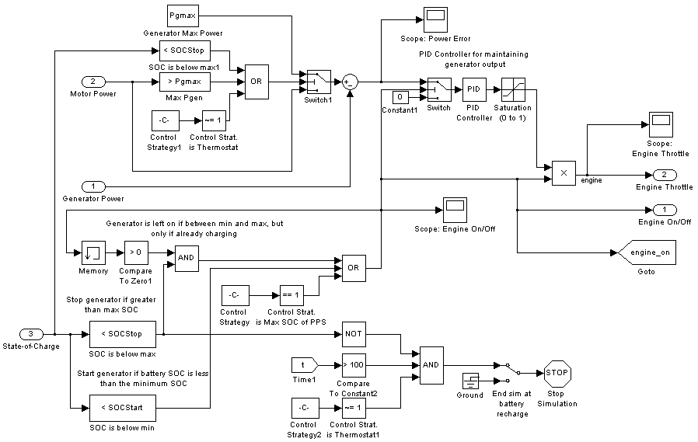
The controller can use two different control strategies described in [3] (pages 256-258). The control strategy is set by changing the ControlStrategy variable in the MATLAB m.code. (0 = thermostat, 1 = max SOC).

Parameters and Variables
SOC_{Start} | SOC to start charging at | 0.6 | unitless
SOC_{Stop} | SOC to end charging at | 0.75 | unitless
P_{gmax} | Maximum generator power | 12500 | W
K_{Pe} | Engine Throttle Proportional gain | 1 | unitless
K_{Ie} | Engine Throttle Integral gain | 0 | unitless
K_{De} | Engine Throttle Derivative gain | 0 | unitless

Thermostat Control Strategy

In this strategy, the vehicle runs off battery power alone when available. The SOC of the battery is maintained between a maximum and a minimum level. When the minimum is reached, the engine-generator is activated to provide power to the motor and to charge the battery. When it reaches the maximum, the engine is deactivated again.

Thermostat control strategy [3]

Generator off/on Logic
The generator should be running if the battery’s SOC is below a specified minimum value (SOCstart). It should then continue to charge until it reaches a specified maximum value (SOCstop).
If the SOC is greater than SOCstart, it should not be activated if off but should be allowed to continue to charge if it is already doing so (the SOC would have a positive slope if it is charging: dSOC/dt > 0).

To account for energy stored in the battery in the fuel economy calculation, the simulation is designed to end with the same level of charge in the batter that it started with. Using this control strategy, the simulation starts with a full battery charge, uses it until depletion, begins recharging, and ends when it reaches the maximum again. The stop behavior can be disabled with the switch in the engine controller subsystem.

Max SOC of PPS Control Strategy
This control strategy attempts to maintain the SOC at a high level rather than using the battery until depletion. It is a strategy designed for vehicles in which performance is the highest concern. The high SOC is meant to ensure that there is enough power in the battery to guarantee high performance at any time. The strategy works through the following method:
- If SOC is below a given level, the engine-generator works at full load, propelling the vehicle and putting the remainder of power in the battery.
- When the battery reaches its top line, it produces power equal to that demanded by the motor only.

Max SOC of PPS strategy [3]

To compare the fuel efficiency of this strategy with the previous one, the simulation is run for the same length of time. This is set in the MATLAB m.code by entering the end time in tstop and setting timelim to 1 to make the simulation stop at this time. Length of time for this simulation is 2194 seconds.

Driver
Compares the current vehicle speed to the target vehicle speed from the driving cycle. The difference is used as an error signal to a PID controller to simulate driver adjustment. This produces a driver throttle/brake adjustment used to control the traction motor speed.
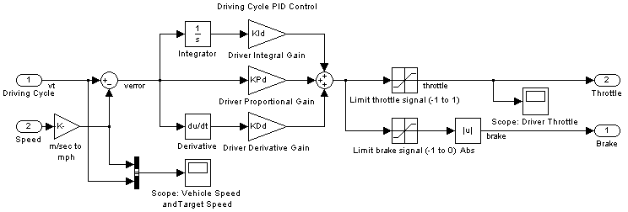

Parameters and Variables
K_{Pd} | Driver Throttle Proportional gain | 10 | unitless
K_{Id} | Driver Throttle Integral gain | 0 | unitless
K_{Dd} | Driver Throttle Derivative gain | 0 | unitless

Driving Cycle
The driving cycle subsystem allows for switching between various driving cycle profiles and controls repetition of the cycles. The cycles are given as desired vehicle speed for each moment of time. Available cycles are:
- UDDS: EPA light vehicle testing cycle simulating city driving conditions (1369 sec) [4]
- HWFET: EPA light vehicle testing cycle simulating highway driving conditions (length: 765 sec) [4]
- Step input: vehicle moves at a constant speed.
- Ramp input: vehicle speed increases at a constant rate (used for determining max speed)

If the current time of the simulation exceeds the length of the driving cycle, the cycle is repeated from the beginning.
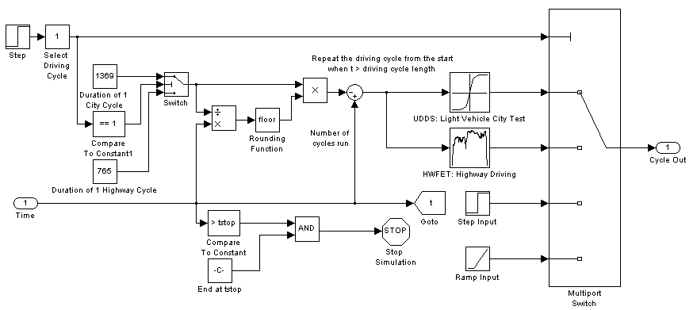

Fuel Economy
Takes measurements of the vehicle’s fuel economy. Fuel economy measurements are fuel used and miles per gallon.
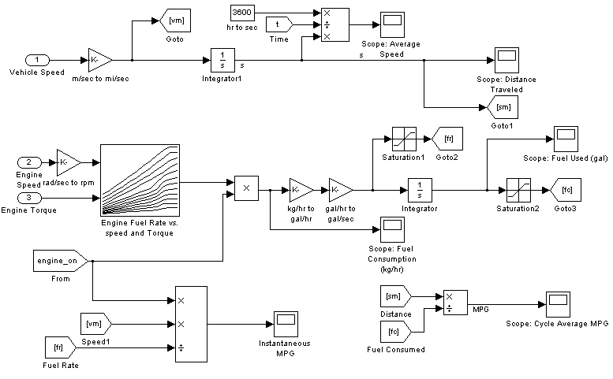

Fuel Rate
The rate of fuel used by the engine is a function of speed and torque. The speed and torque are input to a table of the engine’s fuel rate data to determine the mass flow rate in kg per hour.
$$FR=f\left(ω_{eng},T_{eng}\right)$$
This is converted into gallons per second and then integrated to find the total gallons of fuel used.

MPG
The instantaneous mpg is found by dividing the vehicle’s current speed in miles per second by the fuel consumption rate in gallons per second. The result is also multiplied by the engine on/off signal to give zero if the vehicle is in battery mode with the engine off.
Vehicle speed in miles per second is integrated over time to get the total distance driven. The result is divided by the total fuel used to get the driving cycle’s average fuel economy.

Unit Conversions
Fuel rate data is given in kg/hr. Gallons per second, integrated over time in seconds, are used to find total fuel consumption.
$$\frac{kg}{hr}∙\frac{1m^{3}}{740kg}\frac{264.1721gal}{m^{3}}\frac{1hr}{3600sec}=\frac{gal}{sec}$$

Parameters and variables

Symbol | Description | Value | Units
ω_{eng} | Engine Speed | Input to the subsystem | rad/sec
v_{x} | Vehicle speed | Input to the subsystem | m/sec
T_{eng} | Engine Torque | Input to the subsystem | Nm
fuel density | Density of fuel | 740 | kg/m³

References

[1] Kanber, B. and Baglione, M., "Developing an Extensible and Concise Simulink Toolset for Hybrid Vehicle Modeling and Simulation," SAE Technical Paper 2011-01-0755, 2011, doi:10.4271/2011-01-0755. http://digitallibrary.sae.org/content/2011-01-0755
[2] Su-Ming Fan, Brian. Modeling and Simulation of A Hybrid Electric Vehicle Using MATLAB/Simulink and ADAMS. MS Thesis. University of Waterloo, Ontario, 2007.http://hdl.handle.net/10012/3237
[3] Ehsani, Mehrdad, Yimin Gao, and Ali Emadi. Modern Electric, Hybrid Electric, And Fuel Cell Vehicles, Fundamentals, Theory, And Design. 2nd Ed. CRC, 2010.
[4] United States Environmental Protection Agency. (2010,June 16). Dynamometer Driver's Aid . Retrieved from http://www.epa.gov/nvfel/testing/dynamometer.htm

