Electric-drive Vehicle Lab

Obstacle Avoidance with an Electric Motor-driven Vehicle

Objective
- Demonstrate an electrically-driven vehicle performing obstacle avoidance.
- Understand the implementation of hardware and software needed to perform the obstacle avoidance routine.

Vehicle Overview
The National Instruments DaNI Robotics platform (figure 1) contains sensors, motors, and a control board allowing the robot to be programmed in NI LabVIEW. It is capable of executing an obstacle avoidance program.
In this exercise, the obstacle avoidance behavior of the robot will be demonstrated. Details of the robot’s hardware and how it is used are described below.
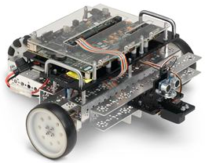
Figure 1: DaNI robot platform [1]
Size | 405 mm x 368 mm x 150 mm (15.9'' x 14.5'' x 5.9'')
Weight | 3.6 kg (7.9 lb)
Wheels | Two Pitsco Education TETRIX 4 in. wheels and one omni wheel for steering
Table 1: Platform specifications

Robot Block Diagram
The block diagram in figure 2 depicts all components of the robot and their connections:
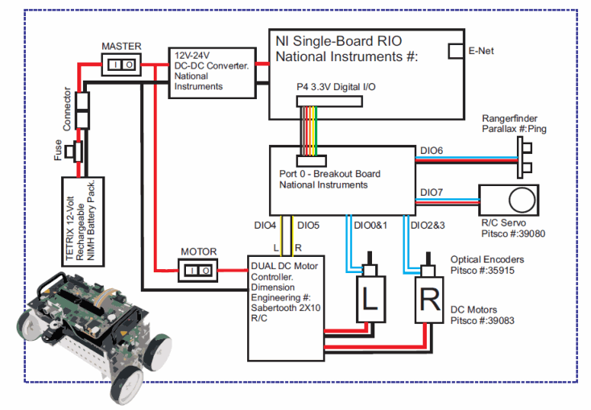
Figure 3: Block diagram of the robot hardware [1]
The robot contains the following:
- Battery Pack (NiMH)  - DC Motor (x2)  - Motor Optical Encoder (x2)  - DC Motor Controller  - DC-DC Converter | - NI Single-Board RIO  - Ultrasonic Sensor  - R/C Servo

Sensor
The robot locates obstacles using an ultrasonic sensor. This sensor emits a short 40 kHz ultrasonic burst traveling at 331.5 m/s which bounces off of objects and then returns to the sensor. The signal output by the sensor is a voltage pulse that begins when the sensor emits an ultrasonic burst and ends when the echo is detected. The duration of the pulse is then proportional to the distance from the sensor to the target which the echo bounced off of. Figure 3 shows the form of the signal pulses. 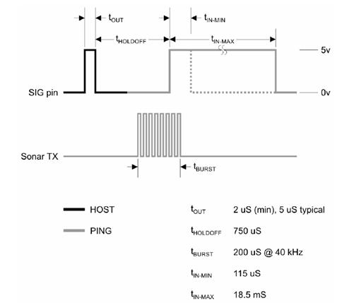
Figure 3: Ultrasonic sensor pulse characteristics [1]
The first short pulse (HOST) is a trigger pulse sent by the host microcontroller. This signals the sensor to emit an ultrasonic pulse (t_{burst}). The second voltage pulse represents the detected echo, with a length ranging from t_{IN-MIN} to t_{IN-MAX} representing the distance to the target. After t_{IN-MAX} the sensor times out: the sensor’s detection range is 2cm to 3m, hence, if the return signal is not detected before t_{IN-MAX}, the nearest obstacle would be outside the sensor’s 3m range and is not detected.
The controller uses the following equation to convert the signal to distance:
$$d=c\frac{t}{2}$$
t = time between signal send and received.
c = speed of sound (343 m/s in air at standard pressure and 20°C)
d = distance to the object reflecting the sound wave.

sbRIO Board
The National Instruments sbRIO Board (single-board reconfigurable input/output, figure 4) is an embedded control and data acquisition system. The board contains a real-time processor, FPGA module (reconfigurable field-programmable gate array), and analog and digital I/O. This board stores the robot control software, which is created on a PC in LabVIEW and transferred using an Ethernet connection. It contains 256 MB of nonvolatile memory for storing programs and data.

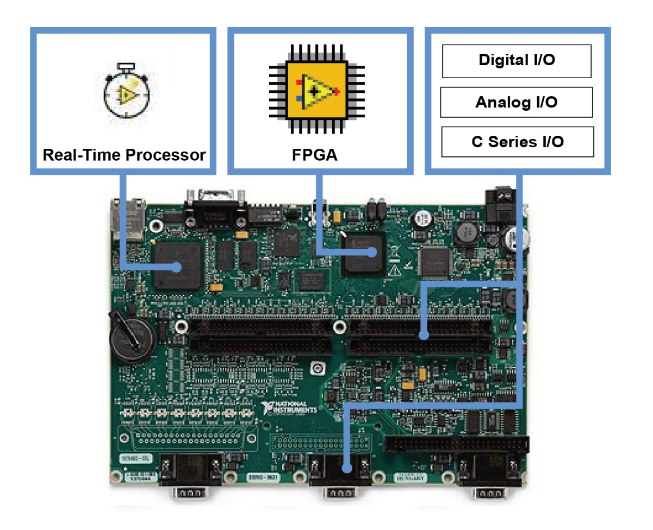
Figure 4: NI sbRIO board [1]

FPGA Module
Field-programmable gate arrays (FPGAs) are reprogrammable silicon chips. In contrast to PC processors, programming an FPGA rewires the chip itself to implement its functionality rather than run a software application.

Motor
The vehicle’s two motors (figure 5) are DC motors rated at 12-volts DC, capable of up to 152 rpm or 300 oz-in of torque. The motor has an internal gear ratio of 1:52.
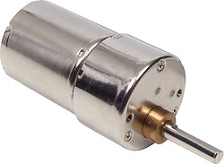  Figure 5: TETRIX DC motor [3] | GENERAL SPECIFICATION FOR TETRIX DC DRIVE MOTOR  W39083  12-volt DC motor features 152 rpm and 300 oz-in. of torque.  Rated Voltage: 12-volt DC  No Load Speed : 146 RPM (nominal) can deviate +/‐ due to manufacturing tolerances  No Load Current : 0.17 Amps  Gear Ratio : 1:52

The motors contain Optical quadrature encoders as sensors for measuring the motor rotation. This type of encoder makes use of a light source and detector. A disc with differently-spaced holes is attached to the motor shaft. As the motor turns, the light is either blocked or allowed to pass through the disc. The sensor outputs this data as a series of on/off pulses, the frequency of which can be used to determine the motor speed. The encoder in this motor produces 400 pulses per revolution.

Motor Controller
The Sabertooth 2X10 R/C motor controller (figure 6) supplies power to the robot’s two DC motors. The controller is a dual motor driver that can supply two DC brushed motors with up to 10A each, with peak currents of 15A possible for a few seconds. It is a regenerative drive that allows for regenerative braking to recharge a battery when the motors are slowed down. The motor driver connects the battery, motors, and sbRIO board. It translates the control signals from the program on the sbRIO board into the actual electric current needed to run the motors at the required performance.
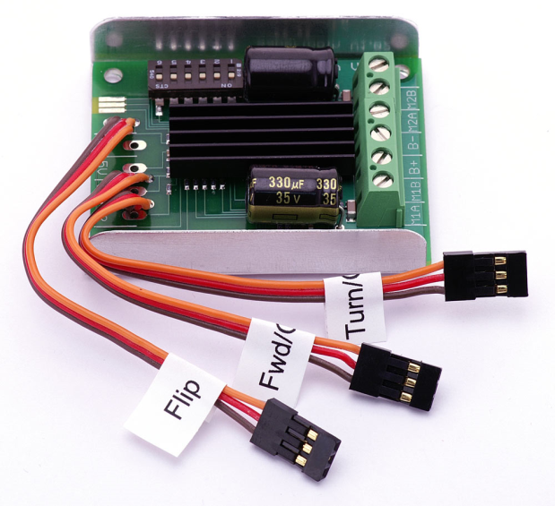
Figure 6: Sabertooth 2X10 R/C motor controller [4]
As seen in figure 2, digital I/O connections DIO4 and DIO5 correspond to the control of the left and right motor from the sbRIO to the motor driver. The control is done through a PWM (pulse width modulation) signal, where the signal is either on or off for pulses of varying length. The result is an average signal which is proportional to the width of the pulses. The duty cycle is the ratio of the time spent on during on pulse to the total length of one pulse. Figure 7 shows PWM signals for several duty cycles.
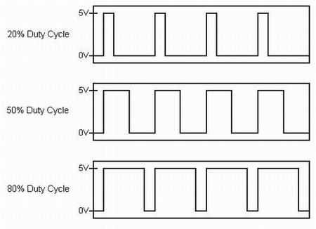
Figure 7: PWM duty cycles

Robot Control Procedure
Figure 8 shows an example of a simple robot control program created in LabVIEW:
Figure 8: Robot control algorithm in LabVIEW
The program is divided into three sections, sense, think, and act (figure 9) which describe the sequence of events the robot performs in executing its movement:

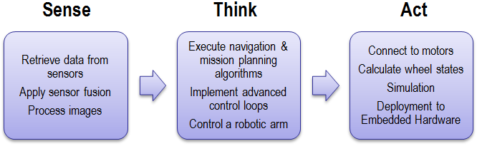
Figure 9: Robot sense-think-act paradigm
- First, data is read from the ultrasonic sensor.
- This data is sent to the control algorithm, which uses it to evaluate the robot’s surrounding area and select the optimal course of action.
- In the above example, the robot is using the Vector Field Histogram (VFH) method to find the steer angle. This algorithm uses the data from the sensor to divide the robot’s surrounding area into a grid of cells containing a probability of an obstacle in that cell, maps the rectangular grid into a polar division of sectors containing the density of obstacles in each sector, and selects the steer angle accordingly to move in a direction closest to the target direction while avoiding the obstacles.
- After determining the direction the robot should proceed in, control signals are sent to the motors which will steer the robot into the chosen course.

References
[1] NI LabVIEW Robotics Starter Kit Robotics Platform for Teaching, Research, and Prototyping. 2011. National Instruments. Mar. 2012 < http://sine.ni.com/ds/app/doc/p/id/ds-217/lang/en >.
[2] King, Robert. " Mobile Robotics Experiments with DaNI." Colorado School of Mines. <http://zone.ni.com/devzone/cda/epd/p/id/6491>.
[4] DC Drive Motor. Pitsco Education. Mar. 2012 <http://shop.pitsco.com/store/detail.aspx?CategoryID=62&pt=22&searchtype=0&by=9&sport=3&c=1&t=2&l=0&ID=5451>.
[4] Sabertooth dual 10A motor driver for R/C. Dimension Engineering LLC. Mar. 2012 <http://dimensionengineering.com/sabertooth2x10rc.htm >.

